# Automate the Web Application (TestNG).

## GitHub Link:

## https://github.com/tamasjit/myjavaproject/tree/master/Phase%205/Phase-5_Practice_Project/q2_Automate_the_Web_Application

## Output:

### Facebook Login Page:

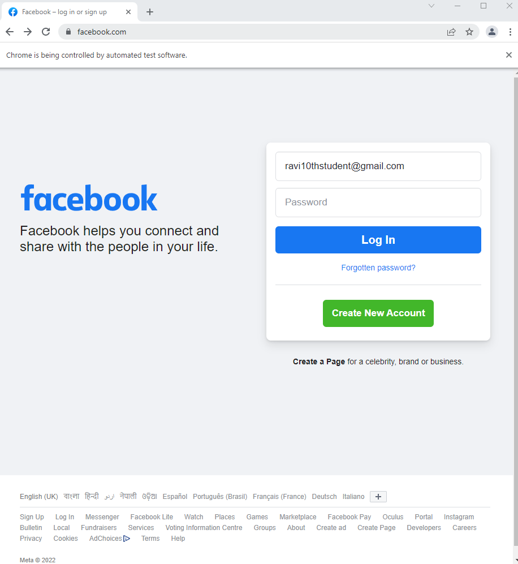

### After Wrong Password Login:

### 

### Console Output (TestNG):

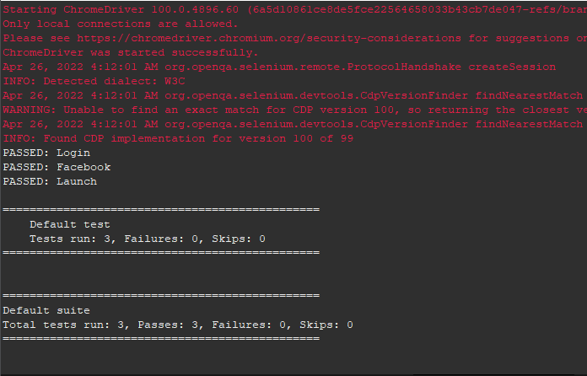

### Junit:

